Bryan Radiology Associates
CT T-spine

Last update: 2021-01-03 JN

Setup:
- Post Myelography patients must be rolled 360 degrees to help evenly distribute spinal contrast
- Scout from S2 through the mid cervical spine with patient’s arms raised above head
- Place bismuth thyroid and/or breast shield after scout(s) have been acquired

Scan Parameters:
- Scan range: mid C6 to mid L1
- Preferred DFOV of 17 cm
- For patients with implanted spinal hardware and/or a BMI ≥ 35 it is suggested that increasing kVp, slowing rotation time, and decreasing the pitch will help to maintain image quality

Reformats:
- Obtain Oblique Axial images when the plane of any disc level is > 15 degrees different from the plane of the scan during the initial acquisition. Typically when patient is kyphotic. Usually tall blocks rather than individual disc levels, only where needed. Include middle level of vertebral body above and middle level of vertebral body below.

PACS Series: (slice thickness x gap)
- 2 x 2 mm AX soft tissue
- 1 x 2 mm AX bone kernel
- 1 x 2 mm SAG bone kernel
- 1 x 2 mm COR bone kernel
- 2 x 2 mm Oblique Axial soft tissue (if done)

See next page
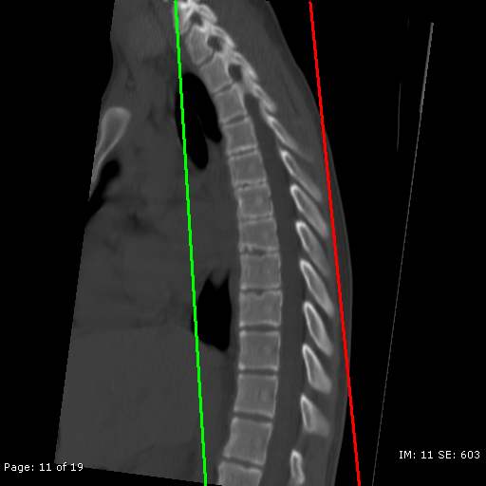
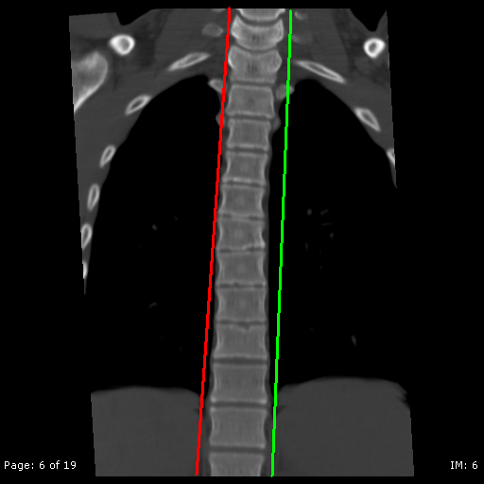

Fig 1: SAG range fig 2: COR range

(both fig from ARA)

Adapted from ARA

